## Problem 1 – Web Hosting Plan

Create a Web page (HTML5 + CSS3 + images) that looks and behaves like the screenshots below:

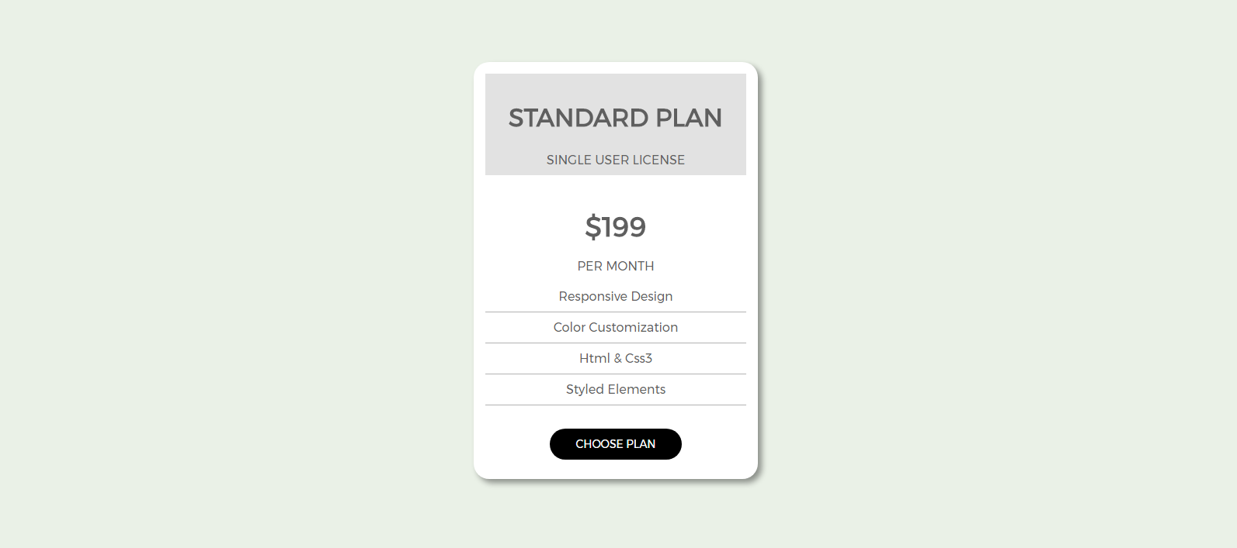

### Input

You are given the above screenshots + all required images + the texts on the site.

### Output

The output should be valid HTML5 + CSS3 + images that implement the above Web page.

### Constraints

* Use google font **Montserrat** - https://fonts.googleapis.com/css?family=Montserrat
* The site should open correctly in the latest version of Chrome
* Pixel-perfect implementation is not required.